### Semester Two Examination, 2018

### Question/Answer booklet

# MATHEMATICS SPECIALIST

**UNITs 3 & 4**

## Section Two:

## Calculator-assumed

|  |
| --- |

Your Name

Your Teacher’s Name

## Time allowed for this section

Reading time before commencing work: ten minutes

Working time: one hundred minutes

## Materials required/recommended for this section

***To be provided by the supervisor***

This Question/Answer booklet

Formula sheet (retained from Section One)

***To be provided by the candidate***

Standard items: pens (blue/black preferred), pencils (including coloured), sharpener, correction fluid/tape, eraser, ruler, highlighters

Special items: drawing instruments, templates, notes on two unfolded sheets of A4 paper, and up to three calculators approved for use in this examination

## Important note to candidates

No other items may be taken into the examination room. It is **your** responsibility to ensure that you do not have any unauthorised material. If you have any unauthorised material with you, hand it to the supervisor **before** reading any further.

| **Question** | **Marks awarded** | **Question** | **Marks awarded** |
| --- | --- | --- | --- |
| **9** |  | **15** |  |
| **10** |  | **16** |  |
| **11** |  | **17** |  |
| **12** |  | **18** |  |
| **13** |  | **19** |  |
| **14** |  | **20** |  |

**Structure of this paper**

| Section | Number of questions available | Number of questions to be answered | Working time (minutes) | Marks available | Percentage of examination |
| --- | --- | --- | --- | --- | --- |
| Section One:  Calculator-free | 8 | 8 | 50 | 51 | 35 |
| Section Two:  Calculator-assumed | 12 | 12 | 100 | 100 | 65 |
|  |  |  |  | **Total** | 100 |

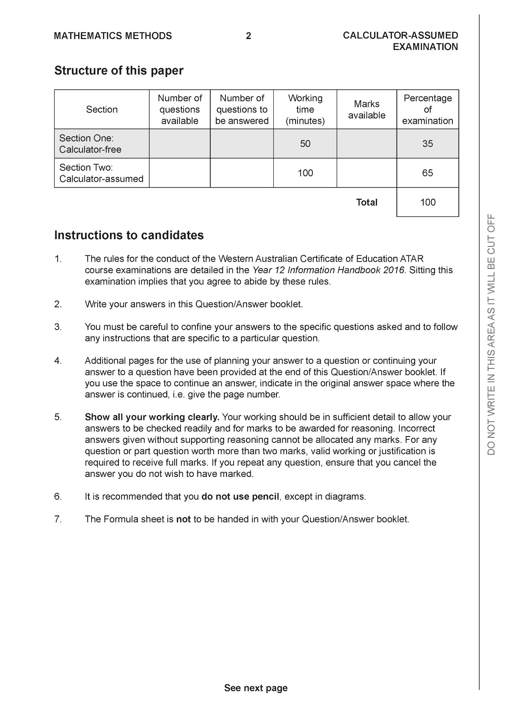

**Section Two: Calculator-assumed (100 Marks)**

This section has **12** questions. Answer **all** questions. Write your answers in the spaces provided.

Spare pages are included at the end of this booklet. They can be used for planning your responses and/or as additional space if required to continue an answer.

● Planning: If you use the spare pages for planning, indicate this clearly at the top of the page.

● Continuing an answer: If you need to use the space to continue an answer, indicate in the original answer space where the answer is continued, i.e. give the page number. Fill in the number of the question that you are continuing to answer at the top of the page.

Working time: 100 minutes.

**Question 9 (6 marks)**

For a brand of Marvel breakfast cereal the weight of cereal in packets that claim to contain

750grams is actually normally distributed with a mean of 758 grams and standard deviation 5

grams.

(a) What percentage of cereal packets will be under the stated weight? (2 marks)

(b) A random sample of 15 packets is selected and the sample mean is taken. What is the probability that the sample mean of these 15 packets is 760 grams when rounded to the nearest gram?

(2 marks)

(c) The confidence interval was obtained for a sample of 15 packets. Determine the level of confidence to 0.1%. (2 marks)



**Question 10 (9 marks)**

1. Determine all the roots of the equation , expressing them all in polar form with and



(3 marks)

(b) Plot all of the above roots on the diagram below. (3 marks)

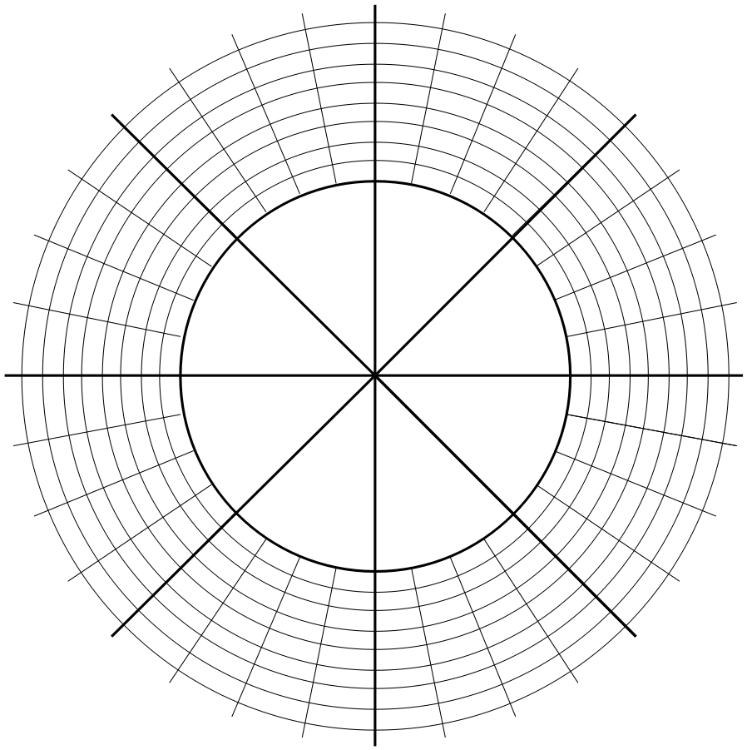

(c) Consider the roots in the first and second quadrants. Determine in polar form,

the midpoint of the line joining these two roots..

(3 marks)

**Question 11 (8 marks)**

The slope field is plotted below for

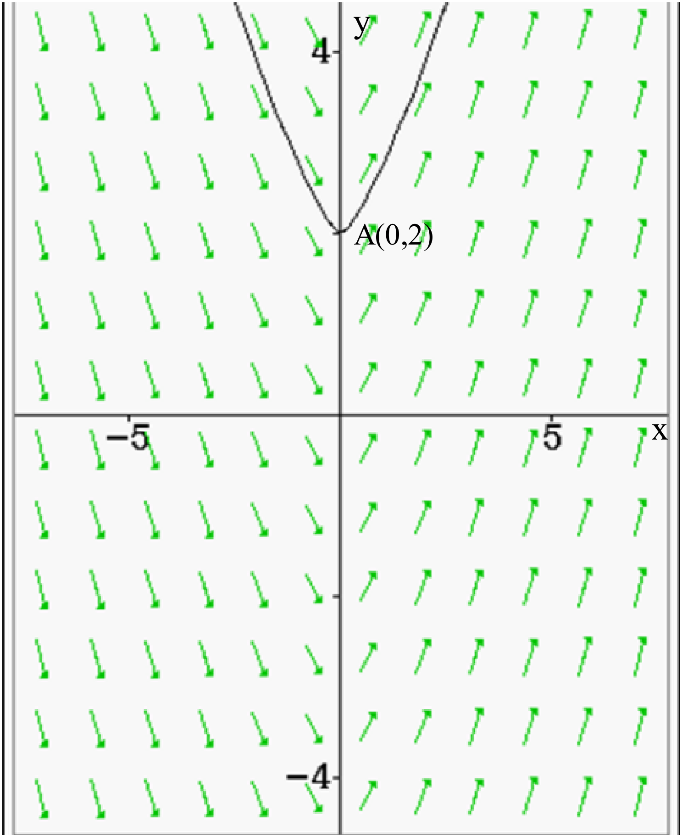

(a) Determine the value of the slope field at point (2 marks)



(b) Determine the equation for the line of force that passes through point



(3 marks)

Q11 cont-

(c) Sketch the slope field for on the diagram below. (3 marks)

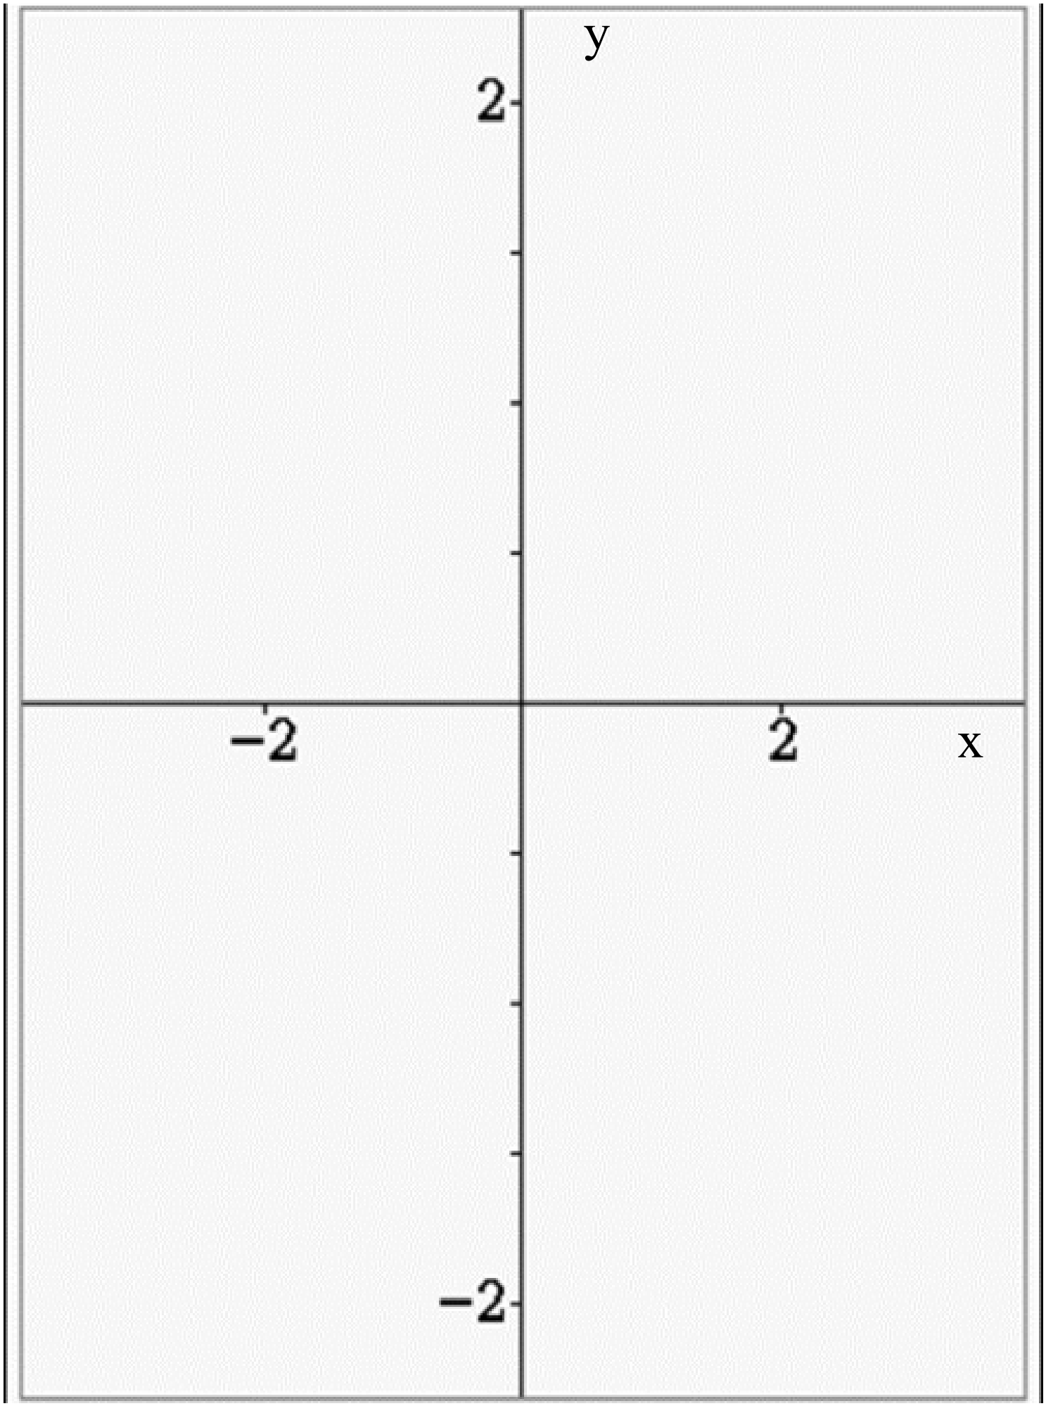

**Question 12 (6 marks)**

A solid sphere of radius 5 cm has a hole drilled through the centre with a diameter of 2 cm. See diagram below. Determine the exact volume of the remaining solid

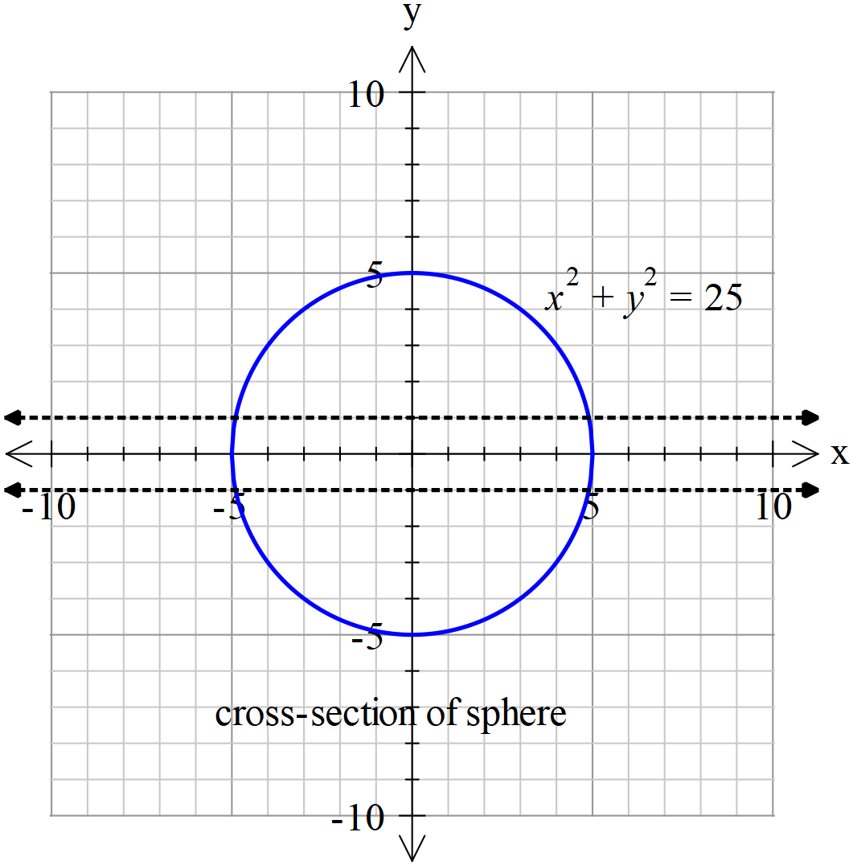

**Question 13 (7 marks)**

Consider the ellipse which contains the point

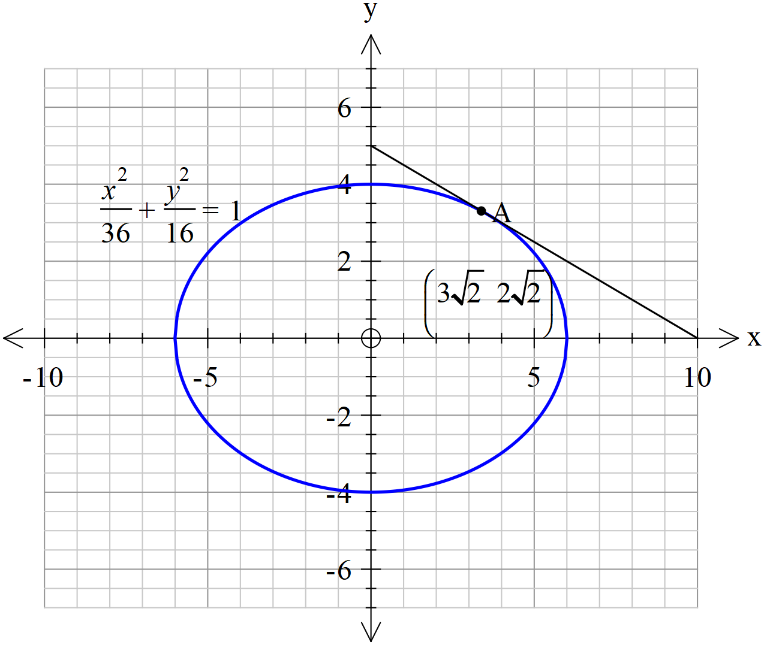

(Note- tangent line is not drawn to scale)

1. Determine the equation of the tangent to the ellipse at point A. (4 marks)
2. Determine the area that is bound between the y axis, ellipse and the tangent line at A above to two decimal places. (3 marks)

**Question 14 (11 marks)**

The working length of an electric cell is found to be Normally distributed. A sample of 20 such electric cells were found to have a sample mean of 1138 working hours and a sample deviation of 250 hours. The customer needs to purchase electric cells that will have a mean working time in excess of 1250 hours.

1. Determine a 95% confidence interval for the population mean working time to two decimal places.

(4 marks)

1. Should the customer buy this type of electric cell? Justify your answer. (2 marks)
2. If a single cell was selected, would you expect the working time to lie in the confidence interval in part a above? Explain. (2 marks)
3. A second sample of cells gave a sample deviation of 250 hours. A 86% confidence interval was calculated to be . Determine the value of . (3 marks)



**Question 15 (12 marks)**

Consider a particle that is projected into the air such that its position vector at any time,

seconds is given by metres.



(a) Determine the exact initial velocity. (2 marks)

(b) Determine the time taken to hit the ground and the horizontal distance covered.

(3 marks)

(c) Determine when seconds. (4 marks)



(d) Determine the total distance travelled through the air to the nearest cm. (3 marks)

**Question 16 (6 marks)**

A boat is moving towards the beach line at metres/minute. On the boat is a rotating light, revolving at 4 revolutions per minute clockwise, as observed from the beach. There is a long straight wall on the beach line, as the boat approaches the beach, the light moves along the wall. Let = the displacement of the light from point on the wall, which faces the boat directly. See diagram below.



Determine the velocity, in metres/minute, of the light on the wall when metres and the distance of the boat from the beach, , is 12 metres.

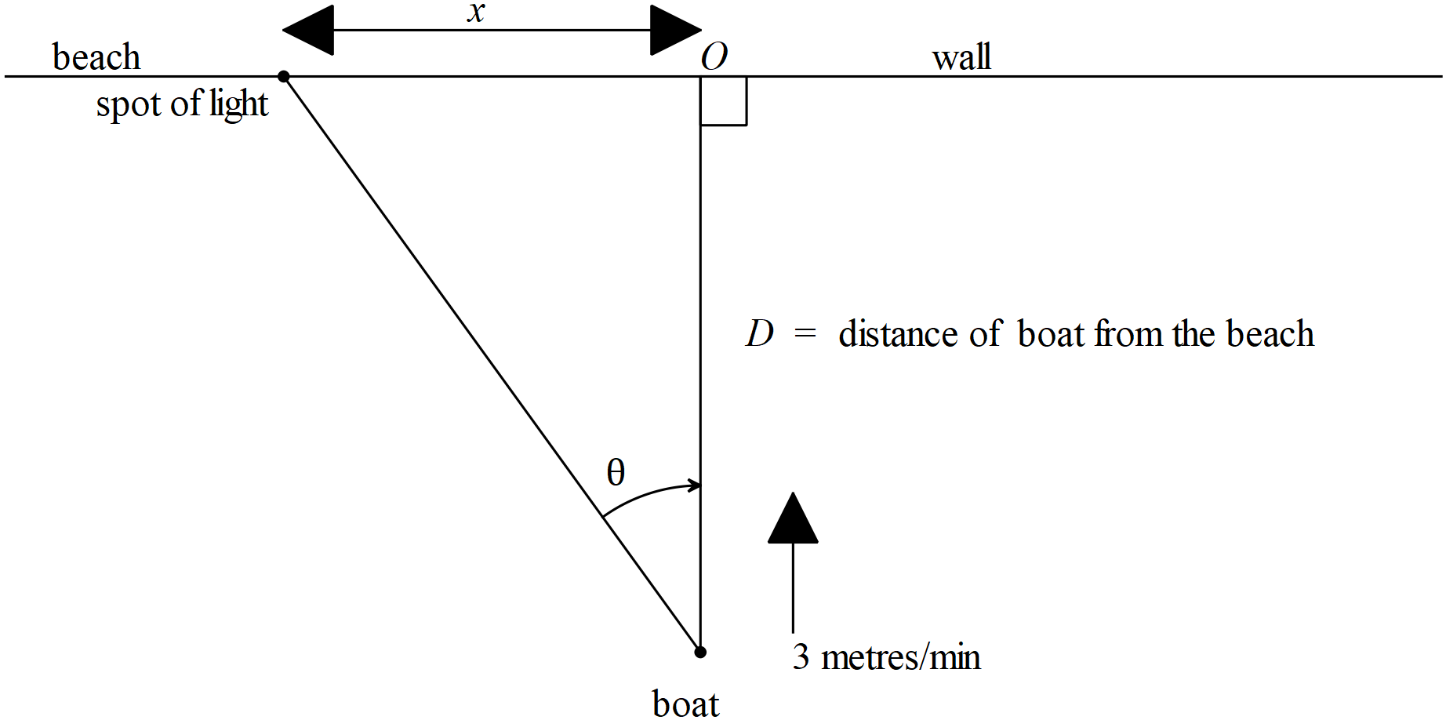

**Question 17 (8 marks)**

The number of bacterial cells, grams, present in a petri dish in a science lab is given by the logistical growth model , at time hours. The initial number of bacteria cells is 5 grams.



(a) Determine the positive value of where . What does the value represent?



(2 marks)

(b) By using separation of variables and partial fractions show that . Determine the value of . (4 marks)



Q17 continued

(c) Determine the time taken for the number of cells to triple. (2 marks)

**Question 18 (10 marks)**

An object oscillates around a fixed point, such that its displacement from , x metres, is given by at time seconds. The maximum speed is metres/second and is also the initial velocity.



(a) Determine the distance from where the speed of the particle will be half of the maximum. (4 marks)



(b) Determine the distance travelled by the particle in the first 2 seconds to the nearest cm.

(3 marks)

(c) Determine the percentage of the time that the particle is more than one quarter of the amplitude away from . (3 marks)



**Question 19 (11 marks)**

Consider a Cartesian equation of the plane and a vector equation of the line



Determine

(a) the position vector of the point of intersection of the line and the plane above.

(3 marks)

(b) the length of the perpendicular from the origin to the line above, to two decimal places.

(3 marks)

(c) a cartesian equation of a new plane which contains the line above and the origin.

(3 marks)

(d) the acute angle between the planes from (a) & (c) above. (2 marks)

**Question 20 (6 marks)**

A policewoman moves along a straight road on a motorcycle with constant speed . Let = distance of policewoman from point on the road. A robber is on a second motorcycle moving on a roundabout of radius .The robber wishes to stay on a line of sight with the policewoman such that this line will always go through the centre of the roundabout as the policewoman approaches point on the road. The centre of the roundabout is units away from the road.



Determine the speed on the roundabout that the robber must move at to maintain the line of sight with the policewoman through the centre of the roundabout in terms of **only**.

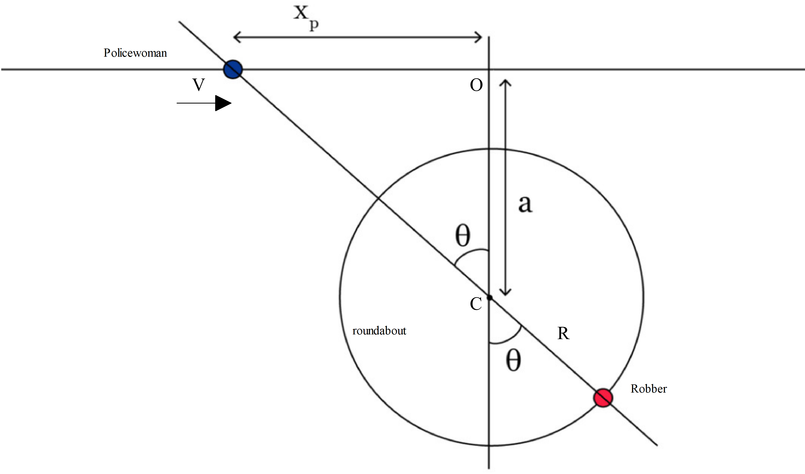

**Additional working space**

Question number:

**Additional working space**

Question number:

**Additional working space**

Question number: